**TABLE OF CONTENTS**

|  |  |  |
| --- | --- | --- |
| **S.No** | **Topic** | **Page No.** |
|  | INTRODUCTION | 3 |
|  | MOTIVATION | 4 |
|  | OBJECTIVE(S) | 5 |
|  | METHODOLOGY/PROCESS FLOW | 6 |
|  | HARDWARE & SOFTWARE REQUIREMENTS | 9 |
|  | SNAPSHOTS OF PROJECT | 10 |
|  | APPLICATION OF PROJECT | 14 |
|  | CONCLUSION | 15 |
|  | FUTURE SCOPE | 16 |
|  | REFERENCES | 17 |

**INTRODUCTION**

The mouse is one of the wonderful inventions of Human-Computer Interaction (HCI) technology. Currently, wireless mouse or a Bluetooth mouse still uses devices and is not free of devices completely since it uses a battery for power and a dongle to connect it to the PC. In the proposed mouse controller system, this limitation can be overcome by employing webcam or a built-in camera for capturing of hand gestures and hand tip detection using computer vision. The algorithm used in the system makes use of the machine learning algorithm. Based on the hand gestures, the computer can be controlled virtually and can perform left click, right click, scrolling functions, and computer cursor function without the use of the physical mouse. The algorithm is based on deep learning for detecting the hands.

**Deep Learning-Based Real-Time AI Motion Controller System**

**[Using Computer Vision]**

This project represents a concept of controlling our video display with the assistance of hand gestures, which relies on one in each of the studies of Human Computer Interaction. This project shows that we are able to control our screen by moving our fingers which will work as cursor. To make this happen, all we need a working webcam and three main algorithms that are, Mediapipe, OpenCV and Autopy. Mediapipe is employed for hand tracking, OpenCV for image processing and drawing and at last Autopy for controlling the mouse movement and its functioning.

**MOTIVATION**

With the development technologies in the areas of augmented reality and devices that we use in our daily life, these devices are becoming compact in the form of Bluetooth or wireless technologies. This report proposes an AI mouse controller system that makes use of the hand gestures and hand tip detection for performing mouse functions in the computer using computer vision.

While using a wireless or a Bluetooth mouse, some devices such as the mouse, the dongle to connect to the PC, and also, a battery to power the mouse to operate are used, but in this paper, the user uses his/her built-in camera or a webcam and uses his/her hand gestures to control the computer mouse operations. In the proposed system, the web camera captures and then processes the frames that have been captured and then recognizes the various hand gestures and hand tip gestures and then performs the particular mouse function.

**OBJECTIVES**

The Proposed Work aims to meet the following objectives (s):

* To describe the technologies used and the programming techniques employed.
* To describe the design and implementation of an alternative to the regular mouse system to perform and control the mouse functions, and this can be achieved with the help of a web camera that captures the hand gestures.
* To evaluate the performance and effectiveness of mouse controller, including any testing or experimentation that was conducted.
* To discuss the potential application and benefits of virtual machine such as its use in research, education or recreational purpose.
* To outline any future work or improvement that could be made to the virtual machine mouse such as adding new features or optimizing performance

**METHODOLOGY/PROCESS FLOW**

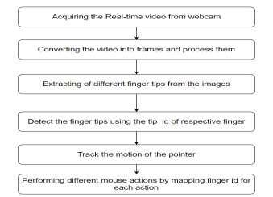

**Algorithm Used for Hand Tracking**

For the purpose of detection of hand gestures and hand tracking, the MediaPipe framework is used, and OpenCV library is used for computer vision. The algorithm makes use of the machine learning concepts to track and recognize the hand gestures and hand tip.

**OpenCV:**

* OpenCV is a computer vision library whichcontains image-processing algorithms for object detection.
* OpenCV is a library of python programming language, and real-time computer vision applications can be developed by using the computer vision library. The OpenCV library is used in image and video processing and also analysis such as face detection and object detection.

**MediaPipe:**

* MediaPipe is a framework which is used forapplying in a machine learning pipeline, and it is an opensource framework of Google. The MediaPipe frame-work is useful for cross platform development since the framework is built using the time series data.
* Single-shot detector model is used for detecting and recognizing a hand or palm in real time. The single-shot detector model is used by the MediaPipe. First, in the hand detection module, it is first trained for a palm detection model because it is easier to train palms. Furthermore, the non-maximum suppression works significantly better on small objects such as palms or fists.
* A model of hand landmark consists of locating 21 joint or knuckle co-ordinates in the hand region, as shown in Figure below:

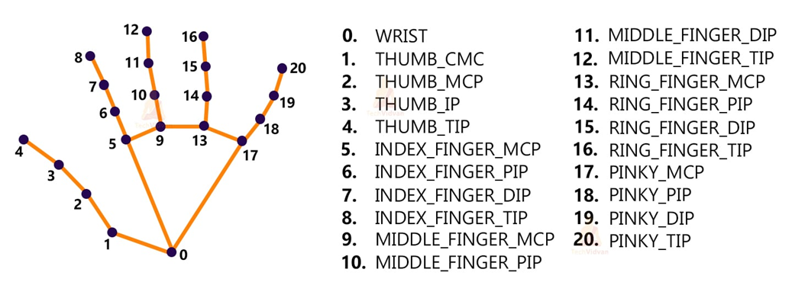

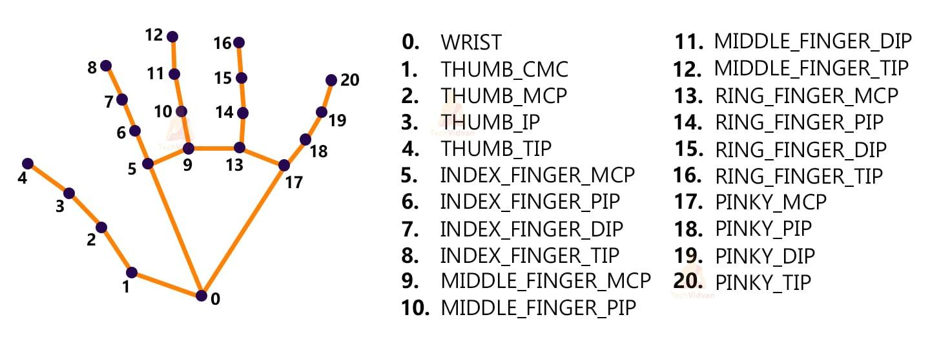

**PyAutoGUI:**

* PyAutoGUI lets your Python scripts control the mouse and keyboard to automate interactions with other applications.
* PyAutoGUI has several features:
* Moving the mouse and clicking in the windows of other applications.
* Sending keystrokes to applications (for example, to fill out forms).
* Take screenshots, and given an image (for example, of a button or checkbox), and find it on the screen.
* Locate an application’s window, and move, resize, maximize, minimize, or close it (Windows-only, currently).
* Display alert and message boxes.
* Using this, different combinations of hand tips are mapped with certain mouse actions. Also, applied some smoothing techniques to prevent flickering during motion.

**HARDWARE & SOFTWARE REQUIREMENTS**

Hardware Requirements:

Laptop/Desktop that has a webcam installed.

Software Requirements:

* Python 3.8/ Python 3.9/ Python 3.10
* PyCharm IDE.
* Import Python Libraries:
* OpenCV
* MediaPipe
* AutoPy
* PyAutoGUI

**Snapshots of project**

1. Detects hand and marks different points on them:



2. All possible functions of the project:



3. Left Click

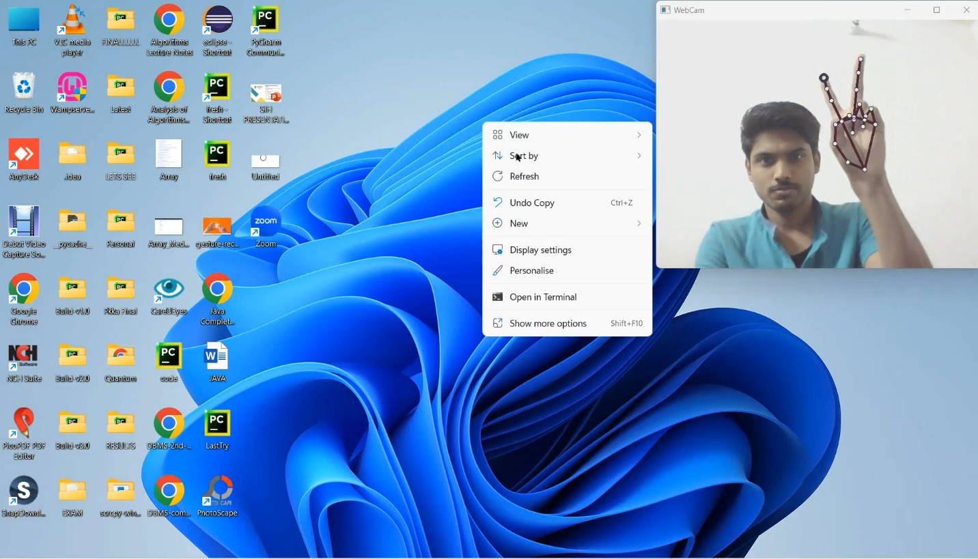

4. Right Click

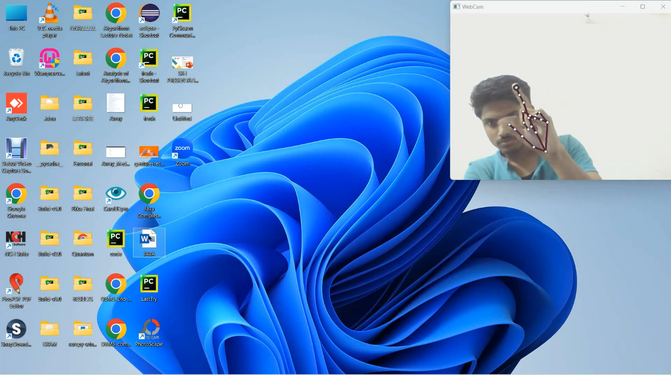

5. Scroll-Up

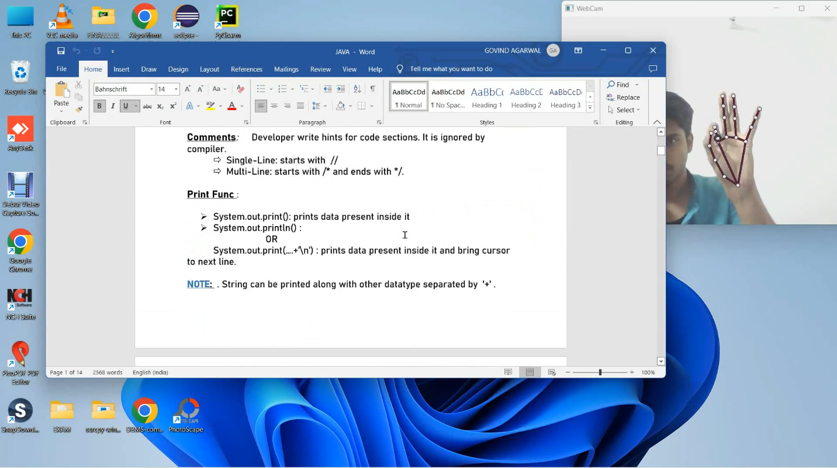

6. Mouse Cursor

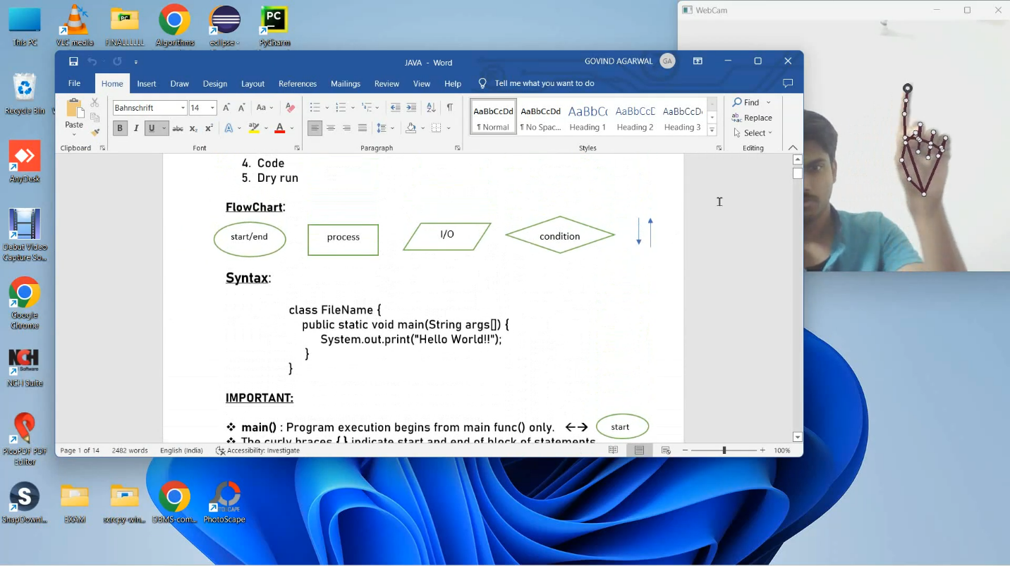

**7. Drag**

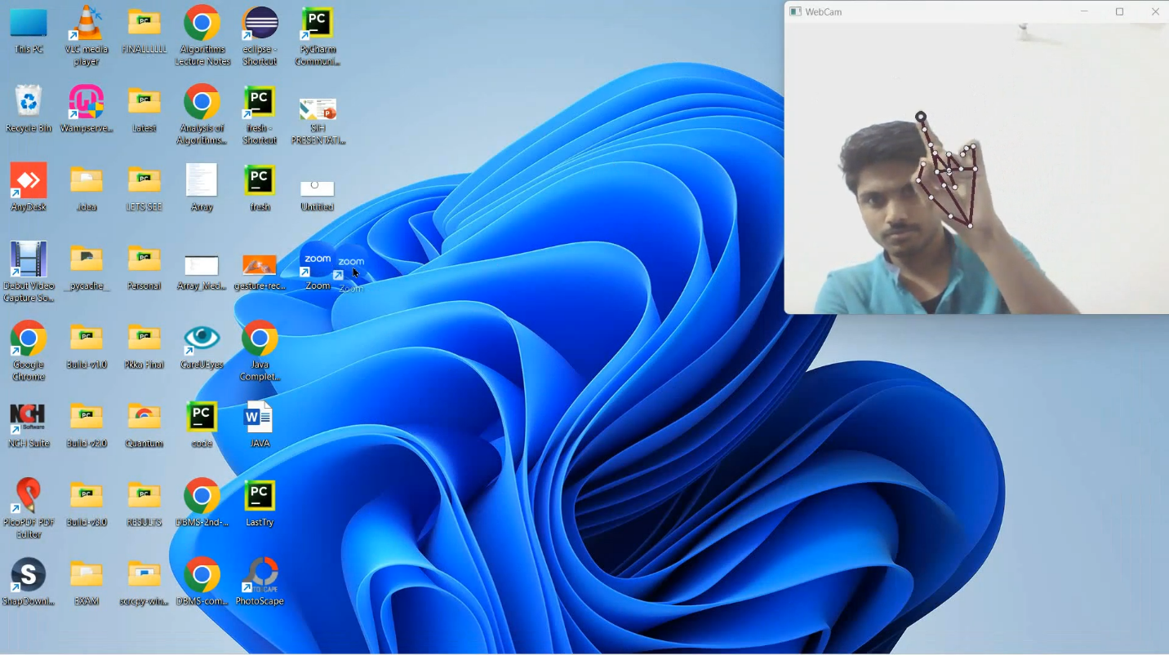

**APPLICATION OF PROJECT**

The AI mouse controller system is useful for many applications; it can be used to reduce the space for using the physical mouse, and it can be used in situations where we cannot use the physical mouse. The system eliminates the usage of devices, and it improves the human-computer interaction.

Major applications:

* 1. Amidst the COVID-19 situation, it is not safe to use the devices by touching them because it may result in a possible situation of spread of the virus by touching the devices, so the proposed AI mouse controller can be used to control the PC mouse functions without using the physical mouse.
  2. The system can be used to control robots and automation systems without the usage of devices
  3. 2D and 3D images can be drawn using the AI virtual system using the hand gestures.
  4. AI mouse controller can be used to play virtual reality-and augmented reality-based games without the wireless or wired mouse devices.
  5. Persons with problems in their hands can use this system to control the mouse functions in the computer.
  6. In the field of robotics, the proposed system like HCI can be used for controlling robots.

**CONCLUSION**

The main objective of the AI virtual mouse system is to control the mouse cursor functions by using the hand gestures instead of using a physical mouse. The proposed system can be achieved by using a webcam or a built-in camera which detects the hand gestures and hand tip and processes these frames to perform the particular mouse functions.

From the results of the model, we can come to a conclusion that the proposed AI virtual mouse system has performed very well and has a greater accuracy compared to the existing models and also the model overcomes most of the limitations of the existing systems. Since the proposed model has greater accuracy, the AI virtual mouse can be used for real-world applications.

**FUTURE SCOPE**

The proposed GlideTech has some limitations such as repeated clicks while keeping gestures for a long time. Also, even when we are not looking into the screen, actions are performed. These are some of the limitations of the proposed AI virtual mouse system, and these limitations will be overcome in our future work.

Furthermore, the proposed method can be developed to handle the keyboard functionalities along with the mouse functionalities virtually which is another future scope of Human-Computer Interaction (HCI).

For security purpose, we may also add retina detection in the same so that :

* 1. Action will be performed only when person is looking in the screen.
  2. Retina detection can be used as identification for the person.

The above-mentioned points are the enhancements that can be done to increase the applicability and usage of this project. We have left all the options open so that if there is any other future requirement in the system by the user or students for the enhancement of the application then it is possible to implement them.

**REFERENCES**

[1]. D. L. Quam, “Gesture recognition with a Data Glove,” IEEE Conference on Aerospace and Electronics, vol. 2, pp. 755–760, 1990.View at: Publisher Site | Google Scholar

[2]. S. U. Duchene, “Cursor control system using hand gesture recognition,” IJARCCE, vol. 2, no. 5, 2013.View at: Google Scholar

[3]. L. Thomas, “Virtual mouse using hand gesture,” International Research Journal of Engineering and Technology (IRJET, vol. 5, no. 4, 2018.View at: Google Scholar

[4]. J. Jaya and K. Thanushkodi, “Implementation of certain system for medical image diagnosis,” European Journal of Scientific Research, vol. 53, no. 4, pp. 561–567, 2011.View at: Google Scholar

[5]. P. Nandhini and J. Jaya, “Image segmentation for food quality evaluation using computer vision system,” International Journal of Engineering Research and Applications, vol. 4, no. 2, pp. 1–3, 2014.View at: Google Scholar © 2022 JETIR April 2022, Volume 9, Issue 4 www.jetir.org (ISSN-2349-5162) JETIR2204334 Journal of Emerging Technologies and Innovative Research (JETIR) www.jetir.org d288

[6]. J. Jaya and K. Thanushkodi, “Implementation of classification system for medical images,” European Journal of Scientific Research, vol. 53, no. 4, pp. 561–569, 2011.View at: Google Scholar

[7]. Google,MP: [https://ai.googleblog.com/2019/08/on -device-real-time-hand-tracking-with.html](https://ai.googleblog.com/2019/08/on%20-device-real-time-hand-tracking-with.html).

[8]. https://google.github.io/mediapipe/solutions/hands : Mediapipe

[9]. https://www.autopy.org/documentation/apireference/mouse.html:Autopy